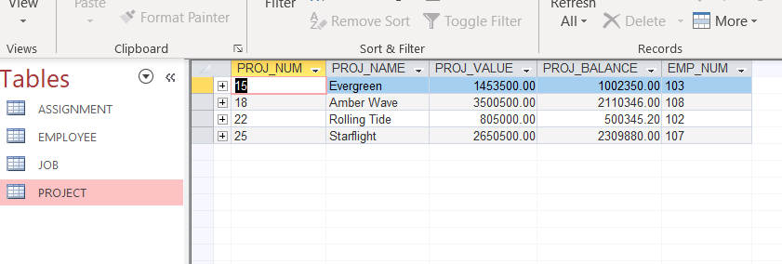

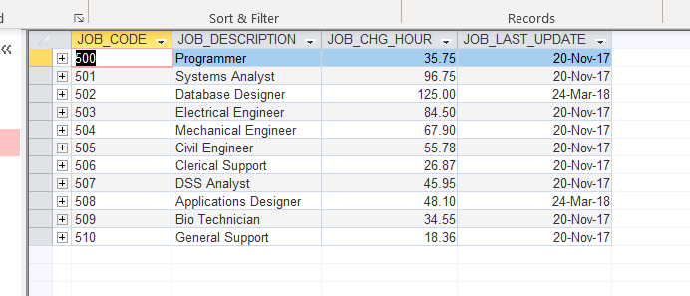

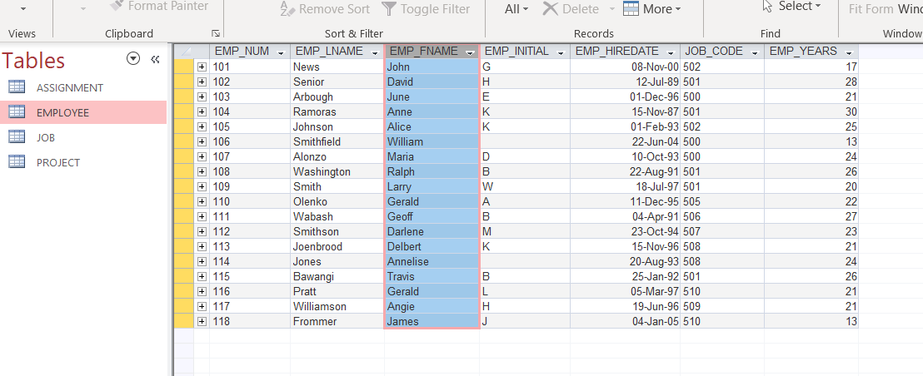

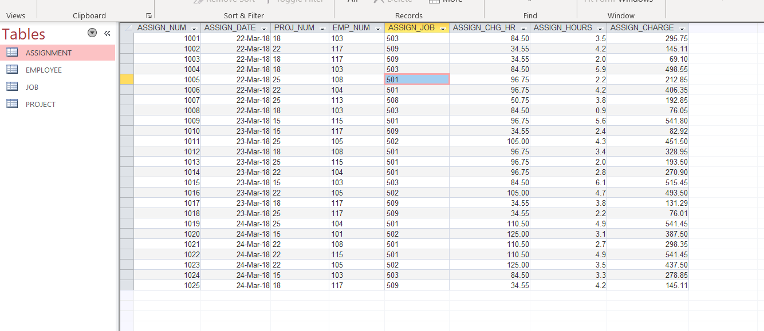

create table PROJECT (

PROJ_NUM varchar(20) primary key,

PROJ_NAME varchar(50),

PROJ_VALUE numeric (10,2),

PROJ_BALANCE numeric (10,2),

EMP_NUM varchar(20)

)

insert into PROJECT values ('15','Evergreen','1453500','1002350','103');

insert into PROJECT values ('18','Amber Wave','3500500','2110346','108');

insert into PROJECT values ('22','Rolling Tide','805000','500345.2','102');

insert into PROJECT values ('25','Starflight','2650500','2309880','107');

create table JOB(

JOB_CODE varchar(20) primary key,

JOB_DESCRIPTION varchar(50),

JOB_CHG_HOUR numeric(10,2),

JOB_LAST_UPDATE datetime

);

INSERT INTO JOB VALUES('500','Programmer', '35.75','11/20/2017');

INSERT INTO JOB VALUES('501','Systems Analyst', '96.75','11/20/2017');

INSERT INTO JOB VALUES('502','Database Designer', '125', '3/24/2018');

INSERT INTO JOB VALUES('503','Electrical Engineer', '84.5', '11/20/2017');

INSERT INTO JOB VALUES('504','Mechanical Engineer', '67.9', '11/20/2017');

INSERT INTO JOB VALUES('505','Civil Engineer', '55.78','11/20/2017');

INSERT INTO JOB VALUES('506','Clerical Support', '26.87','11/20/2017');

INSERT INTO JOB VALUES('507','DSS Analyst', '45.95','11/20/2017');

INSERT INTO JOB VALUES('508','Applications Designer','48.1', '3/24/2018');

INSERT INTO JOB VALUES('509','Bio Technician', '34.55','11/20/2017');

INSERT INTO JOB VALUES('510','General Support', '18.36','11/20/2017');

CREATE TABLE EMPLOYEE(

EMP_NUM VARCHAR(10) PRIMARY KEY,

EMP_LNAME VARCHAR(50),

EMP_FNAME VARCHAR(50),

EMP_INITIAL VARCHAR (10),

EMP_HIREDATE DATETIME,

JOB_CODE VARCHAR(10),

EMP_YEARS INT

);

INSERT INTO EMPLOYEE VALUES('101','News','John','G','11/8/2000','502','4');

INSERT INTO EMPLOYEE VALUES('102','Senior','David','H','7/12/1989','501','15');

INSERT INTO EMPLOYEE VALUES('103','Arbough','June','E','12/1/1996','503','8');

INSERT INTO EMPLOYEE VALUES('104','Ramoras','Anne','K','11/15/1987','501','17');

INSERT INTO EMPLOYEE VALUES('105','Johnson','Alice','K','2/1/1993','502','12');

INSERT INTO EMPLOYEE VALUES('106','Smithfield','William','','6/22/2004','500','0');

INSERT INTO EMPLOYEE VALUES('107','Alonzo','Maria','D','10/10/1993','500','11');

INSERT INTO EMPLOYEE VALUES('108','Washington','Ralph','B','8/22/1991','501','13');

INSERT INTO EMPLOYEE VALUES('109','Smith','Larry','W','7/18/1997','501','7');

INSERT INTO EMPLOYEE VALUES('110','Olenko','Gerald','A','12/11/1995','505','9');

INSERT INTO EMPLOYEE VALUES('111','Wabash','Geoff','B','4/4/1991','506','14');

INSERT INTO EMPLOYEE VALUES('112','Smithson','Darlene','M','10/23/1994','507','10');

INSERT INTO EMPLOYEE VALUES('113','Joenbrood','Delbert','K','11/15/1996','508','8');

INSERT INTO EMPLOYEE VALUES('114','Jones','Annelise','','8/20/1993','508','11');

INSERT INTO EMPLOYEE VALUES('115','Bawangi','Travis','B','1/25/1992','501','13');

INSERT INTO EMPLOYEE VALUES('116','Pratt','Gerald','L','3/5/1997','510','8');

INSERT INTO EMPLOYEE VALUES('117','Williamson','Angie','H','6/19/1996','509','8');

INSERT INTO EMPLOYEE VALUES('118','Frommer','James','J','1/4/2005','510','0');

CREATE TABLE ASSIGNMENT (

ASSIGN_NUM int primary key,

ASSIGN_DATE datetime,

PROJ_NUM varchar(3),

EMP_NUM varchar(3),

ASSIGN_JOB varchar(3),

ASSIGN_CHG_HR numeric(8,2),

ASSIGN_HOURS numeric(8,2),

ASSIGN_CHARGE numeric(8,2)

);

INSERT INTO ASSIGNMENT VALUES('1001','3/22/2018','18','103','503','84.5','3.5','295.75');

INSERT INTO ASSIGNMENT VALUES('1002','3/22/2018','22','117','509','34.55','4.2','145.11');

INSERT INTO ASSIGNMENT VALUES('1003','3/22/2018','18','117','509','34.55','2','69.10');

INSERT INTO ASSIGNMENT VALUES('1004','3/22/2018','18','103','503','84.5','5.9','498.55');

INSERT INTO ASSIGNMENT VALUES('1005','3/22/2018','25','108','501','96.75','2.2','212.85');

INSERT INTO ASSIGNMENT VALUES('1006','3/22/2018','22','104','501','96.75','4.2','406.35');

INSERT INTO ASSIGNMENT VALUES('1007','3/22/2018','25','113','508','50.75','3.8','192.85');

INSERT INTO ASSIGNMENT VALUES('1008','3/22/2018','18','103','503','84.5','0.9','76.05');

INSERT INTO ASSIGNMENT VALUES('1009','3/23/2018','15','115','501','96.75','5.6','541.80');

INSERT INTO ASSIGNMENT VALUES('1010','3/23/2018','15','117','509','34.55','2.4','82.92');

INSERT INTO ASSIGNMENT VALUES('1011','3/23/2018','25','105','502','105','4.3','451.5');

INSERT INTO ASSIGNMENT VALUES('1012','3/23/2018','18','108','501','96.75','3.4','328.95');

INSERT INTO ASSIGNMENT VALUES('1013','3/23/2018','25','115','501','96.75','2','193.5');

INSERT INTO ASSIGNMENT VALUES('1014','3/23/2018','22','104','501','96.75','2.8','270.9');

INSERT INTO ASSIGNMENT VALUES('1015','3/23/2018','15','103','503','84.5','6.1','515.45');

INSERT INTO ASSIGNMENT VALUES('1016','3/23/2018','22','105','502','105','4.7','493.5');

INSERT INTO ASSIGNMENT VALUES('1017','3/23/2018','18','117','509','34.55','3.8','131.29');

INSERT INTO ASSIGNMENT VALUES('1018','3/23/2018','25','117','509','34.55','2.2','76.01');

INSERT INTO ASSIGNMENT VALUES('1019','3/24/2018','25','104','501','110.5','4.9','541.45');

INSERT INTO ASSIGNMENT VALUES('1020','3/24/2018','15','101','502','125','3.1','387.5');

INSERT INTO ASSIGNMENT VALUES('1021','3/24/2018','22','108','501','110.5','2.7','298.35');

INSERT INTO ASSIGNMENT VALUES('1022','3/24/2018','22','115','501','110.5','4.9','541.45');

INSERT INTO ASSIGNMENT VALUES('1023','3/24/2018','22','105','502','125','3.5','437.5');

INSERT INTO ASSIGNMENT VALUES('1024','3/24/2018','15','103','503','84.5','3.3','278.85');

INSERT INTO ASSIGNMENT VALUES('1025','3/24/2018','18','117','509','34.55','4.2','145.11');